Analysis of Tetris code base
This analysis is divide in two parts, first a rundown of three different code patterns that appear in the code base. After that some potential problems that break OOP principals are identified and possible fixes are suggested.

Design Patterns

Template Method Pattern
The class AbstractRotator defines the algorithm for transforming the rows and columns of a 4x4 matrix to what it will be post-rotation. The actual new value of each field in the matrix is calculated by invoking the abstract function rotateMatrixPosition. This function is defined in subclasses to provide the actual details of the rotation. The codebase has two such concrete details: one for rotating clockwise (ClockwiseRotator) and one for rotating anti-clockwise (AntiClockwiseRotator). These are utility classes for applying rotation to 4x4 matrices. This setup is a usage of the template method pattern. See the diagram below.
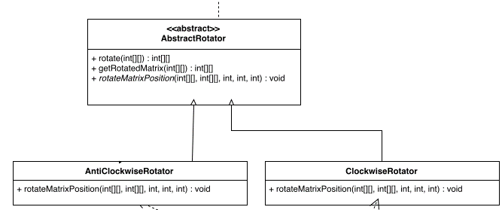
As for usage. The program has a class ShapeLayoutToBoardCellMapper that, as the name suggest, maps a shape to the cells it occupies. It is also responsible for applying rotations, which is where the aforementioned rotators come into play.

Why is the observer pattern used?
The creator of the Tetris, we assume did this unintentionally because his project does not follow the MVC pattern at all. The observer pattern should normally be used for the MVC and since he didn't follow the MVC, maybe he thought that in the future if he would like to add a new interface (Observer) he would simply only need to make board (Observable) implement it.

When is the observer pattern used?
The board is the Observable in this case and the TickListener is the Observer meanwhile the NextShapeGui is the ConcreteObservable. So we found traces of the observer pattern being used when we saw that the Board had a list of TickListener and then has a method of adding the TickListener and the method tick invokes TickListener in a loop. In the GameRunner we found that the NextShapeGui implements the Ticklistener so that is how we interpreted it as the project having an observer pattern.
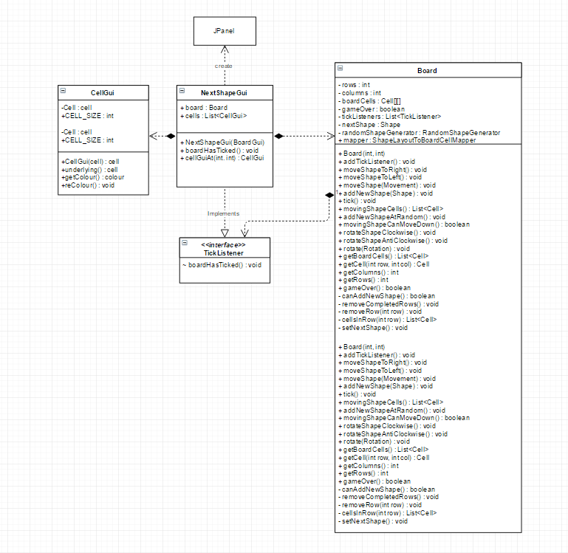

Factory:
Where?
The creator has chosen to apply the factory pattern in the RotatorFactory class. This let him be able to make a rotaion, either clockwise or anticlockwise by using the method: factory.rotate(rotation, int[][]) (factory is an object of RotatorFactory).
Why?
Factory pattern makes it easier for any client to create a rotation. If a client were to create the rotation directly it would have to create an object of class Rotator then use the object to access to the method Rotate() inside the class as well as the method getRotatedMatrix() that it inherits from AbstractRotator which implements the Rotator interface. So it is very clearly that creating a rotation through a factory is quicker and easier. A client who wants to create a rotation only needs to know about what kind of rotation it needs (anticlockwise/clockwise) as well as the rotateMe and nothing else. In addition, factory pattern allows the creator to follow the SOLID principles. In particular, Factories and interfaces give more flexibility for decoupling and therefore increase the degree of DIP (dependency inversion principle) for the whole project.

